# Abstract

Alzheimers disease is terrible.

# Introduction

Something about AD...

# Materials and Methods

## Imaging

An equation:

$$F_{1}=\frac{2⋅TP}{2⋅TP+FP+FN}.$$

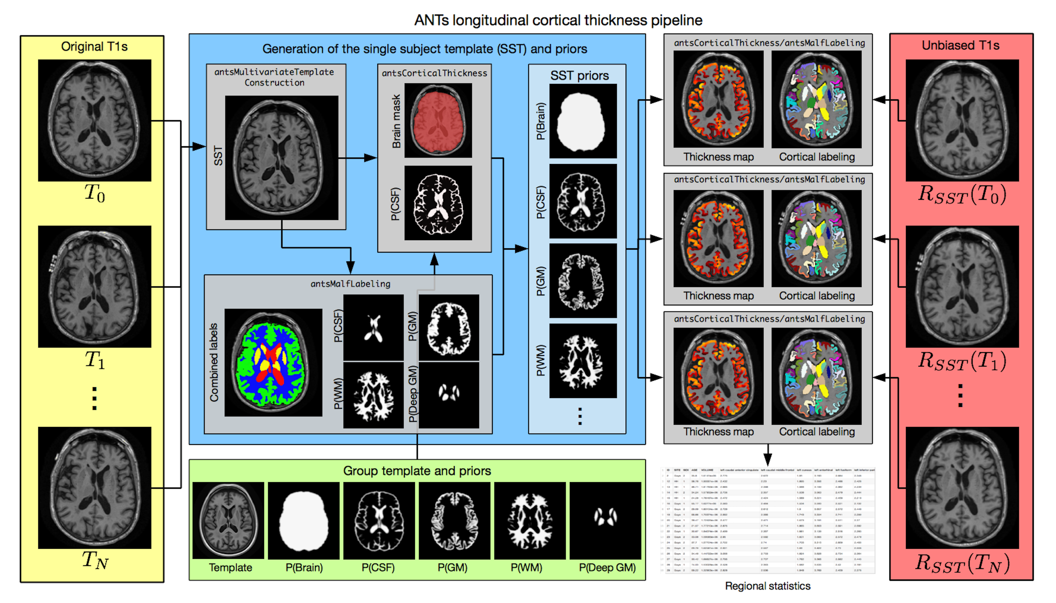

Oh, and here is an image of the longitudinal pipeline with a caption and a reference to the KellyKapowski paper [1].

Here is an example footnote.[1]

# Results

# Discussion

## Subsection 1

And a sweet equation:

1. Tustison, N. J., Cook, P. A., Klein, A., Song, G., Das, S. R., Duda, J. T., Kandel, B. M., Strien, N. van, Stone, J. R., Gee, J. C., and Avants, B. B. “**Large-Scale Evaluation of ANTs and FreeSurfer Cortical Thickness Measurements**” *Neuroimage* 99, (2014): 166–79. doi:[10.1016/j.neuroimage.2014.05.044](https://doi.org/10.1016/j.neuroimage.2014.05.044)

1.